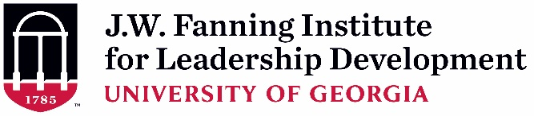
Supervisor Endorsement Form (Rev. 6-27-2022)
(To be completed and signed by Applicant’s Supervisor)

As the supervisor of , I have read the description and participant expectations of the 2022-2023 Region IV Public Health & Primary Care (PHPC) Leadership Institute. If the applicant is selected, I agree to all of the following:

- I will allow time off from regularly assigned duties for her/him to participate in all required activities of the 8-month PHPC Leadership Institute experience including: (~ 40 total hours)
  - In-person opening retreat (October 31 – November 2, 2022; if travel is not safe, there will be a virtual opening retreat 3 hours each day from October 31 – November 3, 2022
  - Six virtual sessions (est. 13 hours).
  - Intersession activities (est. 15 hours)
Time Period | Activity
August 1, 2022 | Application Deadline
By late-September 2022 | Selection Notifications
October 11, 2022, 10-11:30am ET | Virtual Orientation
October 31 – November 2, 2022 * | In-person PHPC LI Retreat  *If travel is not safe, Virtual Retreat October 31 – November 3 (3 hours each day from)
December 2022 – April 2023  Tuesdays @ 10-12:00pm ET | Virtual Sessions:  Dec 6, Jan 10, Feb 7, Mar 7, Apr 4
May 9, 2023, 10 – 1 pm ET | Final Virtual Session: Report, Reflect, Graduate

- I will encourage the participant’s use of newly developed knowledge, skills, attitudes, and competencies in her/his work.

In what ways do you hope this applicant’s participation will benefit your team or organization?

Print or Type Supervisor Contact Information:

Name:
Position/Title:
Organization Name:
E-mail Address:
Telephone Number:

Signature: ______________________________________________ Date: ________
A typed signature is acceptable.

