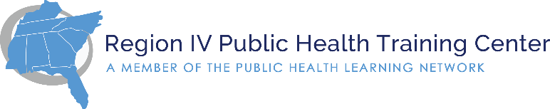
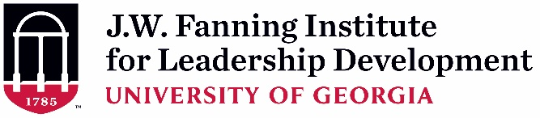

Supervisor Endorsement Form (Rev. 5-25-2021)
(To be completed and signed by Applicant’s Supervisor)

As the supervisor of , I have read the description and participant expectations of the 2021-2022 Region IV Public Health Leadership Institute. If the applicant is selected, I agree to all of the following:

- I will allow time off from regularly assigned duties for her/him to participate in all required activities of the 8-month PHLI experience including: (estimated to be 40 total hours)
  - Virtual retreat (est. 12 hours Nov. 1-4, 2021) and virtual sessions (est. 12 hours)
  - Intersession activities (est. 16 hours)
Time Period | Activity
October 12, 2021 10-11:30am ET | Virtual Orientation
November 1-4, 2021 | Virtual PHLI Session 1 Retreat (est. 12-3pm ET)
December 2021 – May 2022  Tuesdays @ 10am-12:00pm ET | Virtual Sessions:  Dec 7, Jan 11, Feb 1, Mar 1, Apr 5, May 3
May 3, 2022 | Final Virtual Session @ 10am-12:00pm ET

- I will encourage the participant’s use of newly developed knowledge, skills, attitudes, and competencies in her/his work.

In what ways do you hope this applicant’s participation will benefit your team or organization?

Print or Type Supervisor Contact Information:

Name:
Position/Title:
Organization Name:
E-mail Address:
Telephone Number:

Signature: ______________________________________________ Date: ________

A typed signature is acceptable.

